

**By:**

**Rahul Sharma-2K18/MC/087**

**Pritika- 2K18/EE/144**



**MC 310-SOFTWARE ENGINEERING PROJECT**

**SRS**

**Student Management System**

1. **Introduction**

The Student Management System will be used to manage details of student’s Branch, Courses, Sessions, and Results. It manages all the information about Student Results, Course Selection, Session. The project is totally built at administrative end and only the admin is guaranteed the access. The student will only be able to login and view his information.

* 1. **Purpose**

This SRS Document contains the complete software requirements for the Student Management System (SMS) and describes the design decisions, architectural design and the detailed design needed to implement the system. It provides the visibility in the design and provides information needed for software support. New reliable and fast student management software will be developed.

* 1. **Scope**

Student Management System is developing for general purpose and used to replace old paperwork system. SMS is to build upon the existing information system to efficiently provide student information to teachers, students, and university administration. This will increase the efficiency of result making, provide feedback to student, publication and email student result. It provides a mechanism to edit the student information which makes the system flexible.

**1.3 Definitions, Acronyms, And Abbreviations**

IEEE - The Institute of Electrical and Electronics Engineers, Inc.

SMS - Student Management System

SRS - Software Requirements Specification

OS - Operating System

**1.4 References**

1. Software Engineering by K.K. Aggarwal & Yogesh Singh, New Age Publishing House, 2nd Ed.
2. IEEE Recommended Practice for Software Requirements Specifications – IEEE Std 830-1998.
3. **Overall Description**

The student management system allows authorized members to edit the records of academically registered students. It will allow the students to get all their records that is there stored with the college admin.

**2.1. Product Perspective**

The proposed system shall be developed using client/server architecture and be compatible with Microsoft windows operating system. The front end of the system will be developed using HTML and CSS and backend will be developed using Django in python and SQLITE databases.

**2.1.1. User Interfaces**

1. Login: to allow the entry of only authorized users through valid login id and password.
2. Course details: to maintain course details.
3. Branch details: to maintain branch details of a student.
4. Result details: to maintain result details of courses enrolled for a particular branch
5. Faculty details: to maintain the faculty details.

**2.1.2. Hardware interfaces**

* Screen resolution of at least 640 x 480 or above.
* Computer systems will be in the networked environment as it is a multi-user system.

**2.1.3. Software interfaces**

* MS-Windows operating system
* HTML and CSS for designing front-end
* Django and SQLITE databases for backend
* Platform: python
* Integrated development environment(ide): PyCharm

**2.1.4. Memory constraints**

At least 512 mb ram and 500 mb space of hard disk will be required to run the software.

**2.2. Product Functions**

The SMS will allow access only to authorized users with specific roles (system administrator, faculty, and student). Depending upon the user’s role, they will be able to access only specific modules of the system.

A summary of major functions that the user will perform

* + a login facility for enabling only authorized access to the system.
  + system administrators will be able to add, modify or delete course, branch, and course, subjects, results, login information, and students details.
  + students will be able to view their personal and academic details.

**2.3. User characteristics**

* Qualification: at least matriculation and comfortable with English.
* Experience: should be well versed/informed about the registration process of the university.
* Technical Experience: elementary knowledge of computers

**2.4. Constraints**

The delete operation is available only to the administrator. To reduce the complexity of the system, there is no check on delete operation. Hence, the administrator should be very careful before deletion of any record and he/she will be responsible for data consistency.

**2.5. Assumptions and Dependencies**

The login id and password must be created by the system administrator and communicated to the concerned students and faculty confidentially to avoid unauthorized access to the system.

It is assumed that a student registering for the subsequent semester has been promoted to that semester by the university as per rules and has paid the desired university fee.

**2.6. Requirements Subsets**

At present the system would support only single student management but in future the system would be upgraded to manage a network of students.

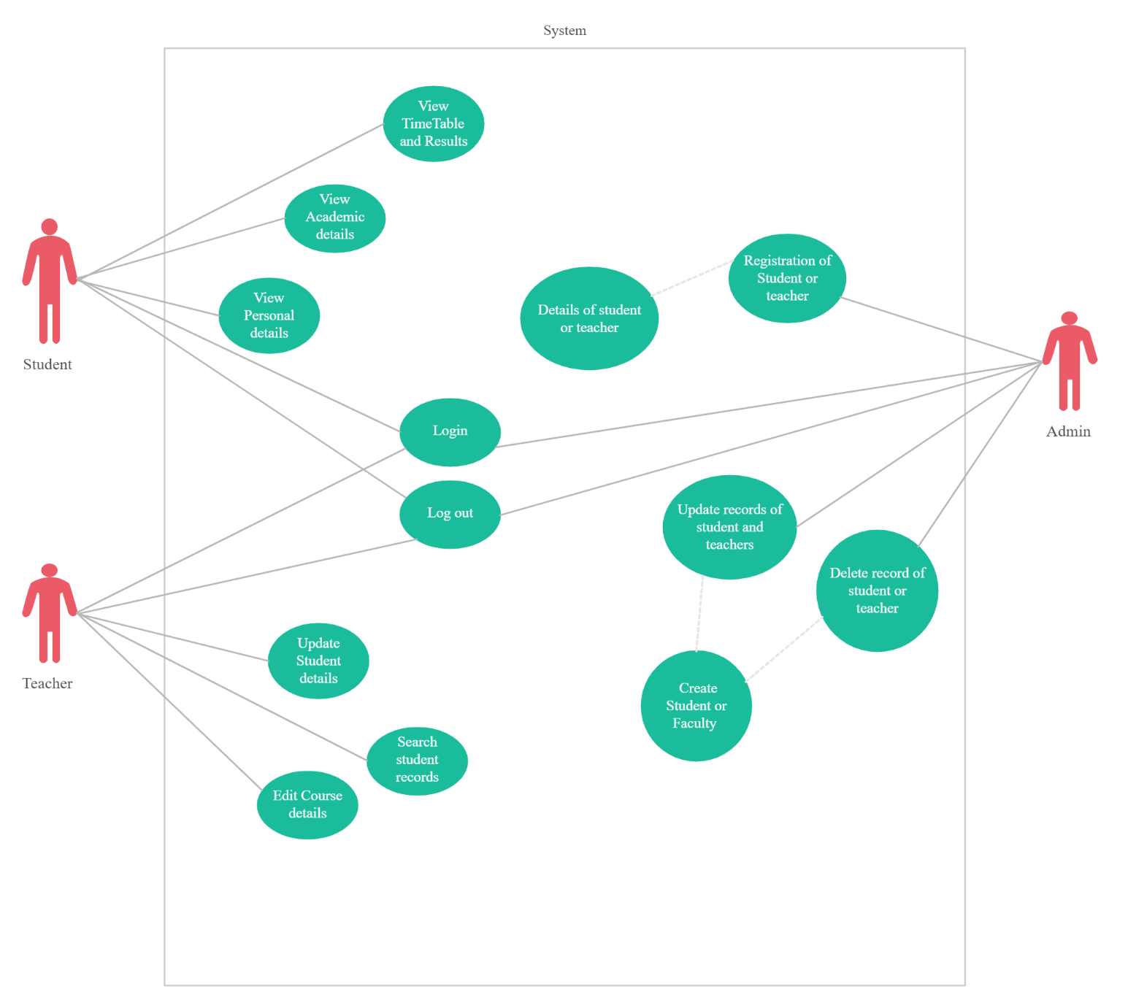

Use case diagram for SMS

**3. Specific Requirements**

**3.1. Functional Requirements**

**3.1.1. Admin Functions**

* Login and selection option from admin menu.
* Edit, create, and delete students and their details
* Edit, create, and delete course, branch, and its details
* Edit, create, and delete faculty and their details etc.

**3.1.2. Faculty Functions**

* Login
* Update student details
* Edit course details
* Check student records

**3.1.3. Student Functions**

* Login
* Check personal details
* Check academic details
* Check result and timetable

**3.2. Performance Requirements**

Though the maximum capacity of the system is 64 terminals, initially it will support only 16 users simultaneously and response time for customer queries must be less than 10 seconds.

**3.3. Design Constraints**

All hardware must support windows XP operating systems. It must also incorporate existing client server software in the product.

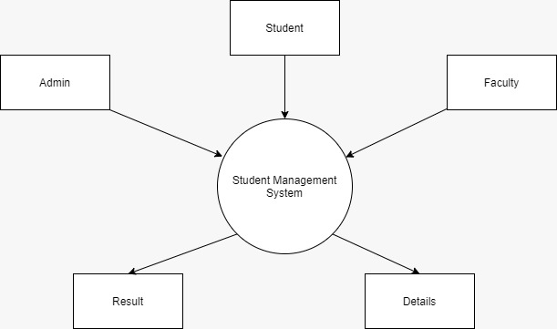

**Level 0 DFD diagram for SMS**

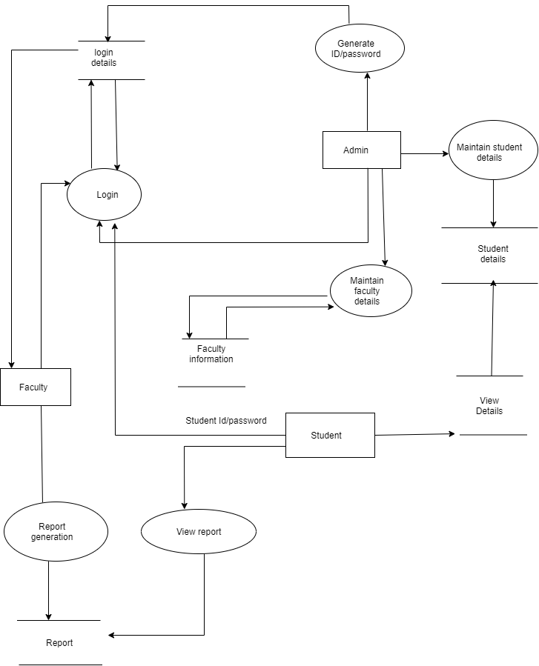

**Level 1 DFD diagram for SMS**